Student Report Card Maker

(Computer Project)

**Made By**

XYZ

Roll No. :

Session : 2012-13

Submitted to

Mr. Rakesh Kumar

D.A.V. Centenary Public School, Chander Nagar, GZB

Certificate

This is to certify that the “Student Report card Maker” is made by ……………………………….Roll No ……………………………………………..and ……………………………………Roll No ………………………………………….

Under my supervision and Guidance. This is their authentic work for the partial fulfillment of computer project work under C.B.S.E. computer Practical Examination for the session 2012-13.

( Rakesh Kumar )

Acknowledgement

This is the right time to express our gratitude towards our teachers/ mentor for their constant support and guidance. These are only few words which we have written here to show our respect to our teachers.

Though they will not among us after this session but their lesson will always guide us in future also.

This project is ousr , but it is their inspiration and constant push that we are now able to compile the whole knowledge we learnt through out 11 & 12, in the form of this project.

Last but not least sir we would love to say thank you.

Yours Sincerely

[ XYX & ABC ]

Index

1. About C++
2. About Student Report card Maker
3. Hierarchical Diagram of Student report card
4. Data required as input
5. Report required as output
6. Classes and their functions
7. Hardware and Software requirement
8. Project Listing
9. Output Screens
10. Reference

About C++

C++ is an "object oriented" programming language created by Bjarne Stroustrup and released in 1985. It implements "data abstraction" using a concept called "classes", along with other features to allow object-oriented programming. Parts of the C++ program are easily reusable and extensible; existing code is easily modifiable without actually having to change the code. C++ adds a concept called "operator overloading" not seen in the earlier OOP languages and it makes the creation of libraries much cleaner.

C++ maintains aspects of the C programming language, yet has features which simplify memory management. Additionally, some of the features of C++ allow low-level access to memory but also contain high level features.

C++ could be considered a superset of C. C programs will run in C++ compilers. C uses structured programming concepts and techniques while C++ uses object oriented programming and classes which focus on data. Read about the [History of C](http://www.hitmill.com/programming/chistory.htm) and also about the [History of C++](http://www.hitmill.com/programming/cpp/cppHistory.html).

About Student Report card Maker

Student report card maker is a simple computer program designed to help teachers to generate students report card after every session.

The whole program is designed in this way that you can expand it up to any level. Initially it is used to feed students information and marks obtained in five subject.

This information is recorded in a binary file “report.dat” , so that this recorded information can be used later on at any stage.

Modification , deletion and searching , reporting facility is given in this project for easy management.

This program is fact and accurate, since it is written in one of the oldest programming language ie C++.

Hierarchical diagram of Project

Data Required as Input

* Admno - To store student admno no
* Name - name of student
* Father Name - father Name of student
* Class & section - class and section of student
* Session - session
* Marks obtained in 5 subject -
* Total Mark - Total marks
* Percentage - percentage marks of student
* Grade - Grade of student

Criteria for Grade calculation

Percentage mark Grade

>=95 A+

<95 and >=90 A

<90 and >=80 B+

<80 and >=70 B

<70 and >=60 C+

<60 C

Output Required

* Single student report card
* Class wise student report card
* Session wise result
* Search - admno
* Search – class & section
* Search – name class & section

Classes & Their function

class report {

private :

int admno;

char name[30];

char fname[30];

int std;

char section;

int phy;

int chem;

int math;

int comp;

int eng;

int total;

float per;

char grade[3];

public :

void main_menu(); //function to display main menu

void search_menu(); // function to display search menu

void report_menu( ); // function to display report menu

void read_data( ); // function to read all the data members from the

//keyboard

void calculate(); // function to calculate total marks, per and grade

void disp_data(); // function to display data members on the screen

void add_record (); // function to add student record in a data file

void del_record (); //function to delete a record from the data file

void modify_record( ); // Function to modify a record in a data file

void search_name( ); //function to read student name and search the Information in the given database file, if it is

// available then display student information otherwise display “ Name does not exist”

void search_admno( ); // function to read student admno and search the Information in the given database file, if it is

void search_class(); // function to read student admno and search the Information in the given database file, if it is

// available then display student information otherwise display “ Name does not exist”

void single_report_card();

void report_single(); // function to show single student report card

void report_class(); // function to show class report of a single class

void report_school(); // fucntion to show class wise report of whole

// school

};

Hardware & software requirement

Hardware required

* 64 MB RAM
* Pentum-1 and Above Processor
* Mouse
* Keyboard

Software Requirement

* Operating System – Windows or any other supported
* C++ Compiler
* IDE ( Integrated Development Environment ) – DEV C++

Program Listing

/*-----Student Report card Maker

made by : 1. XYZ

2. ABC

Session : 2012-13

School Name : DAV Centenary Public School , Chander Nagar, Ghaziabad

*/

#include<iostream>

#include<fstream>

#include<conio.h>

#include<string.h>

using namespace std;

class report {

private :

int admno;

char name[30];

char fname[30];

int std;

char section;

int phy;

int chem;

int math;

int comp;

int eng;

int total;

float per;

char grade[3];

public :

void main_menu(); //function to display main menu

void search_menu(); // function to display search menu

void report_menu( ); // function to display report menu

void read_data( ); // function to read all the data members from the

//keyboard

void calculate(); // function to calculate total marks, per and grade

void disp_data(); // function to display data members on the screen

void add_record (); // function to add student record in a data file

void del_record (); //function to delete a record from the data file

void modify_record( ); // Function to modify a record in a data file

void search_name( ); //function to read student name and search the Information in the given database file, if it is

// available then display student information otherwise display “ Name does not exist”

void search_admno( ); // function to read student admno and search the Information in the given database file, if it is

// available then display student information otherwise display “ Name does not exist”

void search_class(); // function to read student admno and search the Information in the given database file, if it is

// available then display student information otherwise display “ Name does not exist”

void single_report_card();

void report_single(); // function to show single student report card

void report_class(); // function to show class report of a single class

void report_school(); // fucntion to show class wise report of whole

// school

};

/* function to show main menu ------------*/

void report ::main_menu()

{

int choice;

do

{

system("cls");

cout<<"\n\n\n\t\t R e p o r t C a r d M e n u\n\n";

cout<<"\n\n\t\t1. Add New Student ";

cout<<"\n\n\t\t2. Delete Student";

cout<<"\n\n\t\t3. Modify student";

cout<<"\n\n\t\t4. Search Menu";

cout<<"\n\n\t\t5. Report Menu ";

cout<<"\n\n\t\t6. Exit ";

cout<<"\n\n\t\t Enter your choice (1..6) : ";

cin>>choice;

switch(choice)

{

case 1: add_record();// function to call add record

break;

case 2: // function to call delete record

del_record();

break;

case 3: // function to call modify record

modify_record();

break;

case 4: search_menu();

break;

case 5: report_menu();

break;

case 6: break;

default :

cout<<"\n Wrong Choice.... Try agian";

} // end of switch

}while(choice!=6);

return;

}

/*----------- function to create report menu -----------*/

void report ::report_menu()

{

int choice;

do

{

system("cls");

cout<<"\n\n\n\t\t R e p o r t M e n u\n\n";

cout<<"\n\n\t\t1. Single Student";

cout<<"\n\n\t\t2. Single class";

cout<<"\n\n\t\t3. Whole School";

cout<<"\n\n\t\t4. Exit ";

cout<<"\n\n\t\t Enter your choice (1..4) : ";

cin>>choice;

switch(choice)

{

case 1: // function to call single student

report_single();

break;

case 2: // function to display class report

report_class();

break;

case 3: // function to display whole school report card

report_school();

break;

case 4: break;

default :

cout<<"\n Wrong Choice.... Try agian";

} // end of switch

}while(choice!=4);

return;

}

/*------------function to create search menu---------------*/

void report ::search_menu()

{

int choice;

do

{

system("cls");

cout<<"\n\n\n\t\t S e a r c h M e n u \n\n";

cout<<"\n\n\t\t1. Admno Student";

cout<<"\n\n\t\t2. Student Name";

cout<<"\n\n\t\t3. Class wise";

cout<<"\n\n\t\t4. Exit ";

cout<<"\n\n\n\n\t\t Enter your choice (1..4) : ";

cin>>choice;

switch(choice)

{

case 1: // function to call search_admno

search_admno( );

getch();

break;

case 2: // function to call search_name

search_name();

getch();

break;

case 3: // function to call

search_class();

getch();

break;

case 4: break;

default :

cout<<"\n Wrong Choice.... Try agian";

} // end of switch

}while(choice!=4);

return;

}

/*------------function to read data members from keyboard------*/

void report:: read_data( )

{

system("cls");

cout<<"\n Enter Adm No :";

cin>>admno;

cout<<"\n Enter Name : ";

cin>>name;

cout<<"\n Enter Father Name : ";

cin>>fname;

cout<<"\n Enter class : ";

cin>>std;

cout<<"\n Enter Section :";

cin>>section;

cout<<"\n Enter marks obtained in Phyics : ";

cin>>phy;

cout<<"\n Enter marks obtained in Chemistry : ";

cin>>chem;

cout<<"\n Enter marks obtained in Maths : ";

cin>>math;

cout<<"\n Enter marks obtained in computer : ";

cin>>comp;

cout<<"\n enter marks obtaine in emglish : ";

cin>>eng;

return;

}

/*------------function to calculate total marks, per and grade-----------*/

void report::calculate()

{

total = phy+chem+math+comp+eng;

per = total/5.0;

if(per>=95)

strcpy(grade,"A+");

if(per<95 && per>=90)

strcpy(grade,"A");

if(per<90 && per>=80)

strcpy(grade,"B+");

if(per<80 && per>=70)

strcpy(grade,"B");

if(per<70 && per>=60)

strcpy(grade,"C+");

if(per<60)

strcpy(grade,"C");

return;

}

/*---------function to display data members --------------*/

void report::disp_data()

{

cout<<"\n Admno : "<<admno;

cout<<"\n Student Name : "<<name;

cout<<"\n Father Name : "<<fname;

cout<<"\n Class & Section : "<<std<<"-"<<section;

cout<<"\n Physics : "<<phy;

cout<<"\n Chemistry : "<<chem;

cout<<"\n Maths : "<<math;

cout<<"\n Computer : "<<comp;

cout<<"\n English : "<<eng;

cout<<"\n Total Marks : "<<total;

cout<<"\n Percentage : "<<per;

cout<<"\n Grade : "<<grade;

return ;

}

/*-------------function to add record in data file ------*/

void report::add_record ()

{

ofstream fout;

fout.open("report.dat",ios::app);

read_data();

calculate();

fout.write((char*)this, sizeof(report));

fout.close();

}

/*--------------function to search student record name wise ------*/

void report::search_name( )

{

ifstream fin;

fin.open("report.dat");

char tname[30];

int flag=0;

system("cls");

cout<<"\n Enter Name to search :";

cin>>tname;

while(fin.read((char*)this,sizeof(report)))

{

if(strcmpi(tname,name)==0)

{

system("cls");

cout<<"\n Student Information ";

cout<<"\n--------------------------------------------------------"<<endl;

disp_data();

flag=1;

}

}

fin.close();

if(flag==0)

cout<<"\n No such name : "<<strupr(tname)<<" exist in our record... Try again";

return;

}

/*----------function to call search class wise -------------------------------*/

void report::search_class()

{

ifstream fin;

fin.open("report.dat");

char tsect;

int tstd;

int flag;

system("cls");

cout<<"\n Enter student Class to search :";

cin>>tstd;

cout<<"\n Enter student section to search :";

cin>>tsect;

system("cls");

cout<<"\n Class :"<<tstd<<" - "<<tsect<<endl;

cout<<"-------------------------------------------------------------------------------"<<endl;

cout<<"Admno\tName\tFname\t Phy \t Chem\t Math \t Comp \t Eng \t Total \t per\n";

cout<<"-------------------------------------------------------------------------------"<<endl;

while(fin.read((char*)this,sizeof(report)))

{

if(tsect==section && tstd == std)

{

cout<<admno<<"\t"<<name<<"\t"<<fname<<"\t"<<phy<<"\t"<<chem<<"\t"<<math<<"\t"<<comp<<"\t"<<eng<<"\t"<<total<<"\t"<<per<<endl;

flag=1;

}

}

cout<<"-------------------------------------------------------------------------------"<<endl;

fin.close();

if(flag==0)

cout<<"\n\n information Not availabl for class :"<<tstd <<" - "<<tsect;

return;

}

/*------------function to search record according to student admno ------------*/

void report :: search_admno( )

{

ifstream fin;

fin.open("report.dat");

int tadmno;

int flag=0;

system("cls");

cout<<"\n Enter Admission Number to search : ";

cin>>tadmno;

while(fin.read((char*)this,sizeof(report)))

{

if(tadmno == admno)

{

system("cls");

cout<<"\n Student Information ";

cout<<"\n--------------------------------------------------------"<<endl;

disp_data();

flag = 1;

}

}

fin.close();

if(flag==0)

cout<<"\n\n Admission No : "<<tadmno <<" does not exist.... Try again";

return;

}

/*--------function to display single report card---------*/

void report::single_report_card()

{

system("cls");

cout<<"\n\t\t DAV Centenary Public School , Chander Nagar";

cout<<"\n\t\t Session : 2012-13";

cout<<"\n-------------------------------------------------------------------------------";

cout<<"\n\n Admno :"<<admno;

cout<<"\n\n Name :"<<name <<"\t\t Father Name :"<<fname<<"\t\t class :"<<std<<"-"<<section;

cout<<"\n\n-------------------------------------------------------------------------------";

cout<<"\n Subject\tMax Mark\tMin Mark\t Marks Obtained";

cout<<"\n--------------------------------------------------------------------------------";

cout<<"\n Physics\t100\t\t33\t\t\t"<<phy;

cout<<"\n\n Chemistry\t100\t\t33\t\t\t"<<chem;

cout<<"\n\n Maths\t\t100\t\t33\t\t\t"<<math;

cout<<"\n\n Computer\t100\t\t33\t\t\t"<<comp;

cout<<"\n\n English\t100\t\t33\t\t\t"<<eng;

cout<<"\n\n-------------------------------------------------------------------------------";

cout<<"\n Total Marks :\t\t"<<total<<"\t\tPercentage : "<<per<<"\tGrade :"<<grade;

cout<<"\n---------------------------------------------------------------------------------";

return;

}

/*----------function to show single student report-----*/

void report:: report_single()

{

int tadmno;

int flag =0;

ifstream fin;

fin.open("report.dat",ios::binary); //binary mode

system("cls");

cout<<"\n Enter admission No : ";

cin>>tadmno;

while(fin.read((char*)this, sizeof(report))) // read record and check eof

{

if(tadmno ==admno)

single_report_card(); // function to display single report card

else

flag =1;

}

fin.close();

if(flag==0)

cout<<"\n\n Admission No :"<<tadmno <<" does not exist.... Try again";

getch();

return;

}

/*-------------function to display class wise report card------------*/

void report:: report_class()

{

int tstd;

char tsect;

int row =6;

int no =0;

ifstream fin;

fin.open("report.dat");

system("cls");

cout<<"n\n Enter Class (1..12) :";

cin>>tstd;

cout<<"\n Enter section :";

cin>>tsect;

system("cls");

cout<<"\n\t\t D.A.V. Centenary Public School Chander Nagar, GZB";

cout<<"\n\t\t Class :"<<tstd<<"-"<<tsect<<"\t\t Session : 2012-13"<<endl;

cout<<"-------------------------------------------------------------------------------"<<endl;

cout<<"Admno\tName\tFname\t Phy \t Chem\t Math \t Comp \t Eng \t Total \t per\n";

cout<<"-------------------------------------------------------------------------------"<<endl;

while(fin.read((char*)this, sizeof(report)))

{

if(tstd==std && tsect== section )

{

row= row+1;

no++;

if(row>=30)

{

cout<<"\n\n Press any key to continue ................";

getch();

cout<<"\n\t\t D.A.V. Centenary Public School Chander Nagar, GZB";

cout<<"\n\t\t Class :"<<tstd<<"-"<<tsect<<"\t\t Session : 2012-13"<<endl;

cout<<"-------------------------------------------------------------------------------"<<endl;

cout<<"Admno\tName\tFname\t Phy \t Chem\t Math \t Comp \t Eng \t Total \t per\n";

cout<<"-------------------------------------------------------------------------------"<<endl;

row =6;

}

cout<<admno<<"\t"<<name<<"\t"<<fname<<"\t"<<phy<<"\t"<<chem<<"\t"<<math<<"\t"<<comp<<"\t"<<eng<<"\t"<<total<<"\t"<<per<<endl;

}

}

fin.close();

cout<<"-------------------------------------------------------------------------------"<<endl;

cout<<"\n Total Student : "<<no<<" Report prepared By :"<<" Rakesh Kumar ";

getch();

return ;

}

/*-------------function to prepare whole school report card-----------------------*/

void report:: report_school()

{

int tstd;

char tsect;

int row =6;

int no =0;

ifstream fin;

fin.open("report.dat");

system("cls");

cout<<"\n\t\t D.A.V. Centenary Public School Chander Nagar, GZB";

cout<<"\n\t\t Class :"<<tstd<<"-"<<tsect<<"\t\t Session : 2012-13"<<endl;

cout<<"-------------------------------------------------------------------------------"<<endl;

cout<<"Admno\tName\tFname\t Phy \t Chem\t Math \t Comp \t Eng \t Total \t per\n";

cout<<"-------------------------------------------------------------------------------"<<endl;

while(fin.read((char*)this, sizeof(report)))

{

row= row+1;

no++;

if(row>=30)

{

cout<<"\n\n Press any key to continue ................";

getch();

cout<<"\n\t\t D.A.V. Centenary Public School Chander Nagar, GZB";

cout<<"\n\t\t Class :"<<tstd<<"-"<<tsect<<"\t\t Session : 2012-13"<<endl;

cout<<"-------------------------------------------------------------------------------"<<endl;

cout<<"Admno\tName\tFname\t Phy \t Chem\t Math \t Comp \t Eng \t Total \t per\n";

cout<<"-------------------------------------------------------------------------------"<<endl;

row =6;

}

cout<<admno<<"\t"<<name<<"\t"<<fname<<"\t"<<phy<<"\t"<<chem<<"\t"<<math<<"\t"<<comp<<"\t"<<eng<<"\t"<<total<<"\t"<<per<<endl;

}

fin.close();

cout<<"-------------------------------------------------------------------------------"<<endl;

cout<<"\n Total Student : "<<no<<" Report prepared By :"<<" Rakesh Kumar ";

getch();

return ;

}

/*------------function to delete single record from binay file report.dat------*/

void report::del_record ()

{

ifstream fin;

ofstream fout;

int tadmno;

int flag =0;

system("cls");

cout<<"\n Enter admno to delete :";

cin>>tadmno;

fin.open("report.dat",ios::binary);

fout.open("temp.dat");

while(fin.read((char*)this, sizeof(report)))

{

if(tadmno!=admno)

fout.write((char*)this,sizeof(report));

else

flag=1;

}

fin.close();

fout.close();

remove("report.dat"); // function from stdio.h header file

rename("temp.dat","report.dat"); // function from stdio.h header file

if(flag==1)

cout<<"\n\n Record Sucessfully removed ";

else

cout<<"\n Admission No :"<<tadmno <<" does not exist...Try again";

getch();

return;

}

/*---------function to modify student information-----------------------*/

void report:: modify_record( )

{

ifstream fin;

ofstream fout;

int tadmno;

int flag =0;

system("cls");

cout<<"\n Enter Admno to Modify :";

cin>>tadmno;

fin.open("report.dat",ios::binary);

fout.open("temp.dat");

while(fin.read((char*)this, sizeof(report)))

{

if(tadmno == admno)

{ read_data(); calculate(); flag=1; }

fout.write((char*)this,sizeof(report));

}

fin.close();

fout.close();

remove("report.dat"); // function from stdio.h header file

rename("temp.dat","report.dat"); // function from stdio.h header file

if(flag==1)

cout<<"\n\n Record Sucessfully modified ";

else

cout<<"\n Admission No :"<<tadmno <<" does not exist...Try again";

getch();

return;

}

/*-----------main function to implement report class ------------*/

int main()

{

report r;

r.main_menu();

return 0;

}

OUTPUT SCREENS

Main Menu

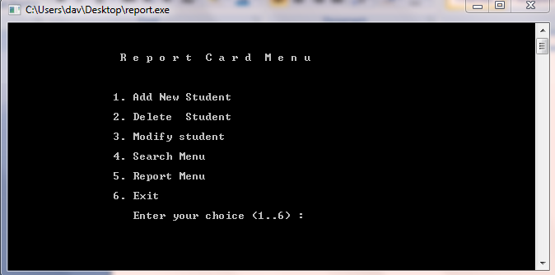

Add Student Record

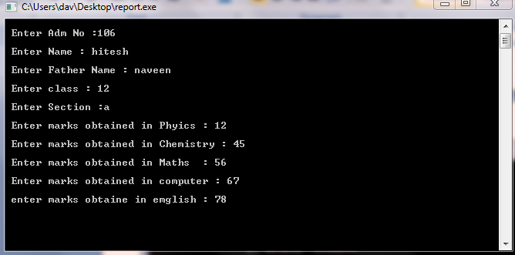

Modify Record

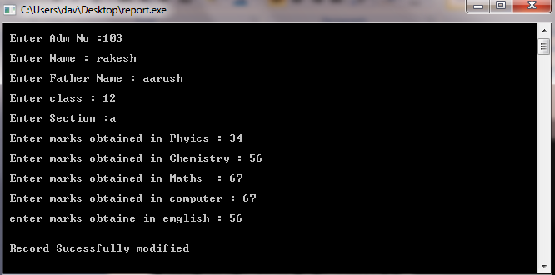

Search Menu

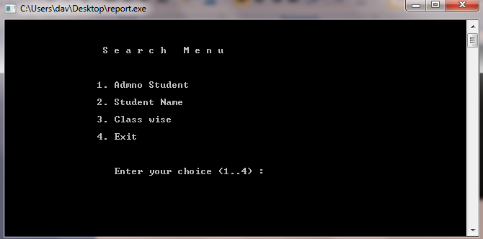

Report Menu

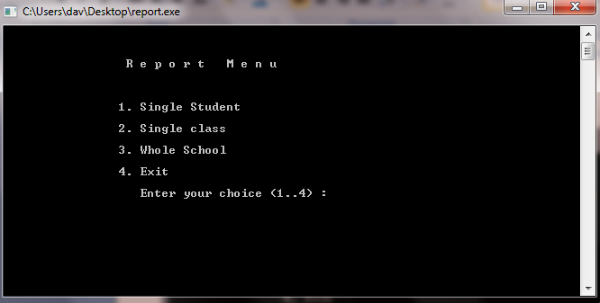

Single student report card

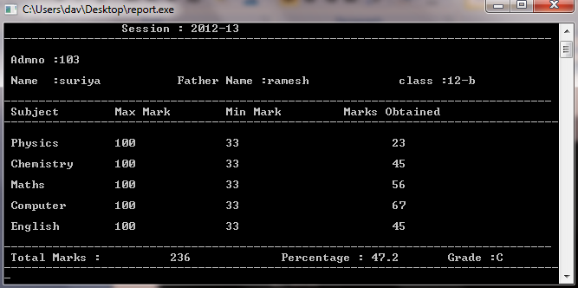

Class wise report

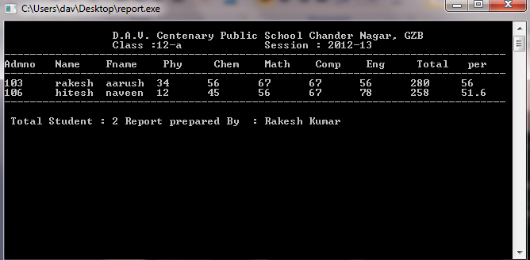

Reference

1. Computer Projects
   * + 1. By – Rakesh Kumar
2. Computer science
   * + 1. By Sumita Arora
3. The art and Science of Computer Project
   * + 1. SitePoint
4. Online reference
   * + 1. [www.pscode.com](http://www.pscode.com)
       2. [www.about.com](http://www.about.com)
       3. [www.programmersheaven.com](http://www.programmersheaven.com)
       4. www.class-12-computer-project.blogspot.in